**Bug Report Examples using a web page dedicated for practical purposes only.**

**Bug Title: Slow Loading page**  
**Bug Priority: High**

**Hardware & Software Details**  
=======================

Environment: Computer  
OS & Browser: Windows 11, Edge Browser

Build Version: 132  
  
**Steps to Reproduce**

=======================

1. Go to the link page

**Current Behavior**

=======================

The web page takes to much time to respond, and sometimes the server seems totally down.

**Expected Behavior**

=======================

The page should not take to much time to load.

Please take a look at the attached screenshot.



**Bug Title: Search bug**  
**Bug Priority: Medium**

**Hardware & Software Details**  
=======================

Environment: Computer  
OS & Browser: Windows 11, Edge Browser

Build Version: 132  
  
**Steps to Reproduce**

=======================

1. Go to the link page
2. Go to the section “Hotels”
3. Click on the button with the search icon

**Current Behavior**

=======================

The web page seems to no wait the full results of the search, which causes that if the user finds a potential option could lose it in a few seconds.

**Expected Behavior**

=======================

The page should wait for the full results and the load it or load it but paginated at the end for a better experience.

Please take a look at the behavior in the attached video.

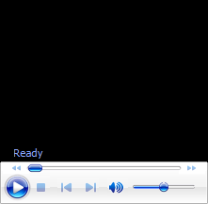

**Bug Title: UI/UX improvements**  
**Bug Priority: Low**

**Hardware & Software Details**  
=======================

Environment: Computer  
OS & Browser: Windows 11, Edge Browser

Build Version: 132  
  
**Steps to Reproduce**

=======================

1. Go to the link page

Please take a look at the attached screenshot. The first picture shows how in computers with more width screen display the text. The picture with red draw indicates a possible improvement for the layout. The expected dimensions when this occurs it’s from 800x1280 and 900x1440 (laptops with that screen).

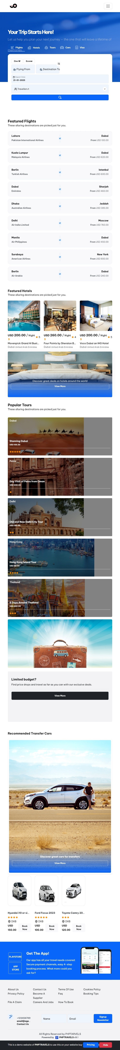



**Bug Title: UI/UX improvements**  
**Bug Priority: Low**

**Hardware & Software Details**  
=======================

Environment: Computer, iPad  
OS & Browser: Windows 11, Edge Browser, iOs Chrome

Build Version: 132  
  
**Steps to Reproduce**

=======================

1. Go to the link page
2. Click on the buttom “Login”

Please take a look at the attached screenshot. The red draw indicates a possible improvement for the layout. The expected dimensions when this occurs it’s from 768x1024 (iPad) and 900x1440 (laptops with that screen).

**Bug Title: UI/UX improvements**  
**Bug Priority: Low**

**Hardware & Software Details**  
=======================

Environment: Computer  
OS & Browser: Windows 11, Edge Browser

Build Version: 132  
  
**Steps to Reproduce**

=======================

1. Go to the link page

Please take a look at the attached screenshot. The red draw indicates a possible improvement for the messages, it could be an unnoticed alert for the user when there are no matches in some search. Could use a paragraph below the search field.

